Dr. Surendra Kumar
Dept. of Economics
M.A. III Sem.
Economic Growth And Development
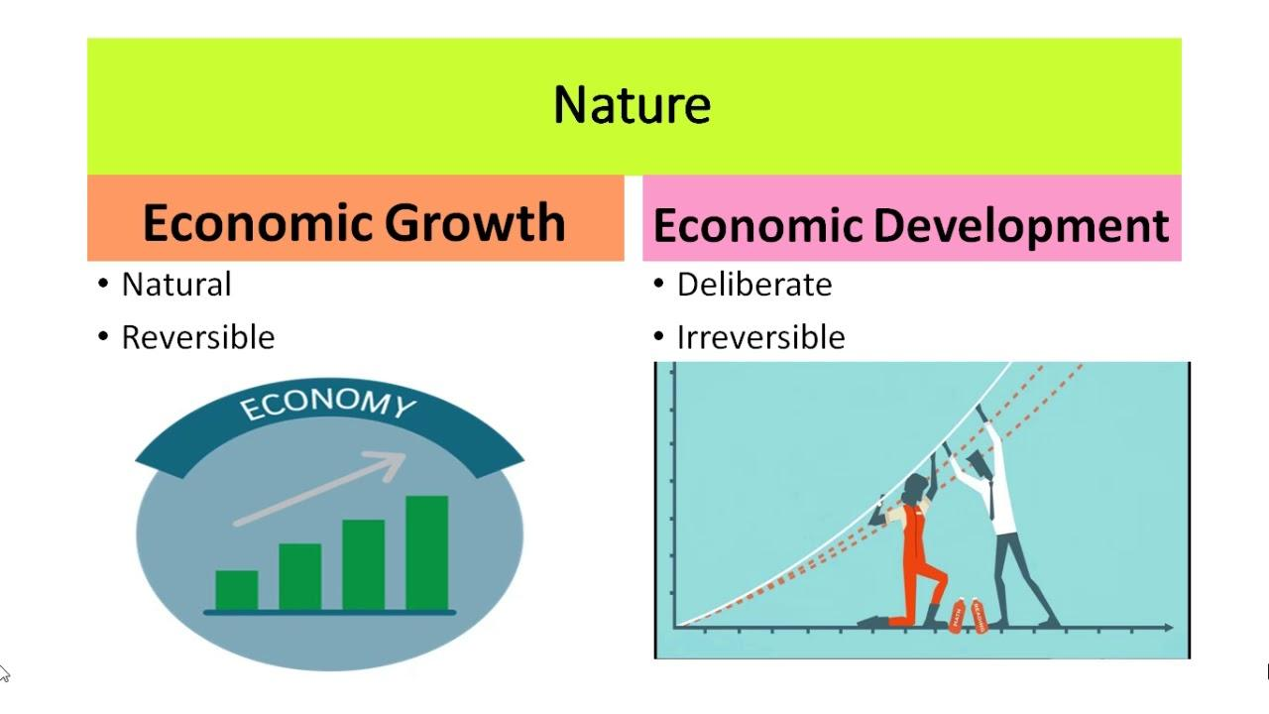Economic growth and development tends to appear same usually but on seeing it economically there appears a vast difference in both the terms. Economic growth represents the increase in the per capita income and in overall amount of goods and services in developed countries while economic development depicts the same meaning i.e, increase in the per capita income and in overall amount of goods and services in developing countries.
Economic Growth:-
Economic growth is an increase in the production of economic goods and services, compared from one period of time to another. It can be measured in nominal or real (adjusted for inflation) terms. Traditionally, aggregate economic growth is measured in terms of gross national product (GNP) or gross domestic product (GDP), although alternative metrics are sometimes used.
In simplest terms, economic growth refers to an increase in aggregate production in an economy. Often, but not necessarily, aggregate gains in production correlate with increased average marginal productivity. That leads to an increase in incomes, inspiring consumers to open up their wallets and buy more, which means a higher material quality of life or standard of living.
In economics, growth is commonly modeled as a function of physical capital, human capital, labor force, and technology. Simply put, increasing the quantity or quality of the working age population, the tools that they have to work with, and the recipes that they have available to combine labor, capital, and raw materials, will lead to increased economic output.
Ways to generate economic growth:-
1. Increase in the amount of physical goods
2. Technological improvement
3. Growth in Labour force
4. Increase in human capital
Economic Development:-
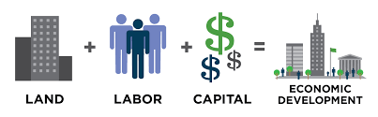
According to Amartya Sen, development is about creating freedom for people and removing obstacles to greater freedom. Greater freedom enables people to choose their own destiny. Obstacles to freedom, and hence to development, include poverty, lack of economic opportunities, corruption, poor governance, lack of education and lack of health.
Economic development is the process by which emerging economies become advanced economies. In other words, the process by which countries with low living standards become nations with high living standards. Economic development also refers to the process by which the overall health, well-being, and academic level the general population improves.
During the development, there is a population shift from agriculture to industry, and then to services.
A longer average life expectancy, for example, is one of the results of economic development. Improved productivity, higher literacy rates, and better public education, are also consequences.
Put simply; economic development is all about improving living standards. ‘Improved living standards’ refers to higher levels of education and literacy, workers’ income, health, and life spans.
Economic development looks at how the citizens of a country are affected. Apart from their living standards, it also looks at the freedom they have to enjoy those living standards.
Economic development takes into account the following information:
- Average life expectancy, i.e., how long people people’s life spans are.
- Education standards.
- Literacy rates, i.e., what percentage of the population can read.
- Environmental standards.
- Availability of housing, plus the quality of housing.
- Access to healthcare. This takes into account the number of doctors per thousand people, access to affordable medicine, etc.
- Income per capita

Economic development – example
Let’s suppose there are two countries, X and Y. The two countries have exactly 1,000 people each. These countries are fictitious extremes.
Looking just at GDP
Y’s GDP is $40 million, while that of X is $21 million.
Y’s and X’s GDP per capita are $40,000 and $21,000 respectively.
If we just look at GDP per capital, Y appears to be a richer country. However, we do not know whether it is more economically developed.
Taking into account other features
Mr. Greed, Y’s richest person, received $39 million of the country’s $40 million GDP. Mr. Posh, X’s richest person, received $1 million of the country’s $21 million GDP.
If we take out the richest person in each country, GDP per capita is:
- Y: $1,000
- X: $20,000
In X, 99% of the population is literate, while in Y it is 60%. X has free universal healthcare. In Y, on the other hand, only half the population has access to affordable health care.
For every mile of road and railway track in Y, X has 6 miles and 11 miles respectively.
Average life expectancy is X is eight years longer than in Y.
Therefore, as far as economic development is concerned, X is way ahead of Y.

